**(1) Plot the dataset :**

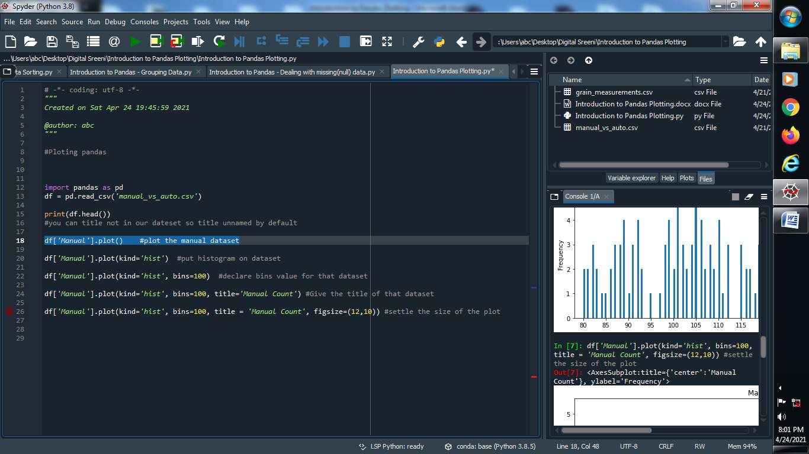

**Output :**

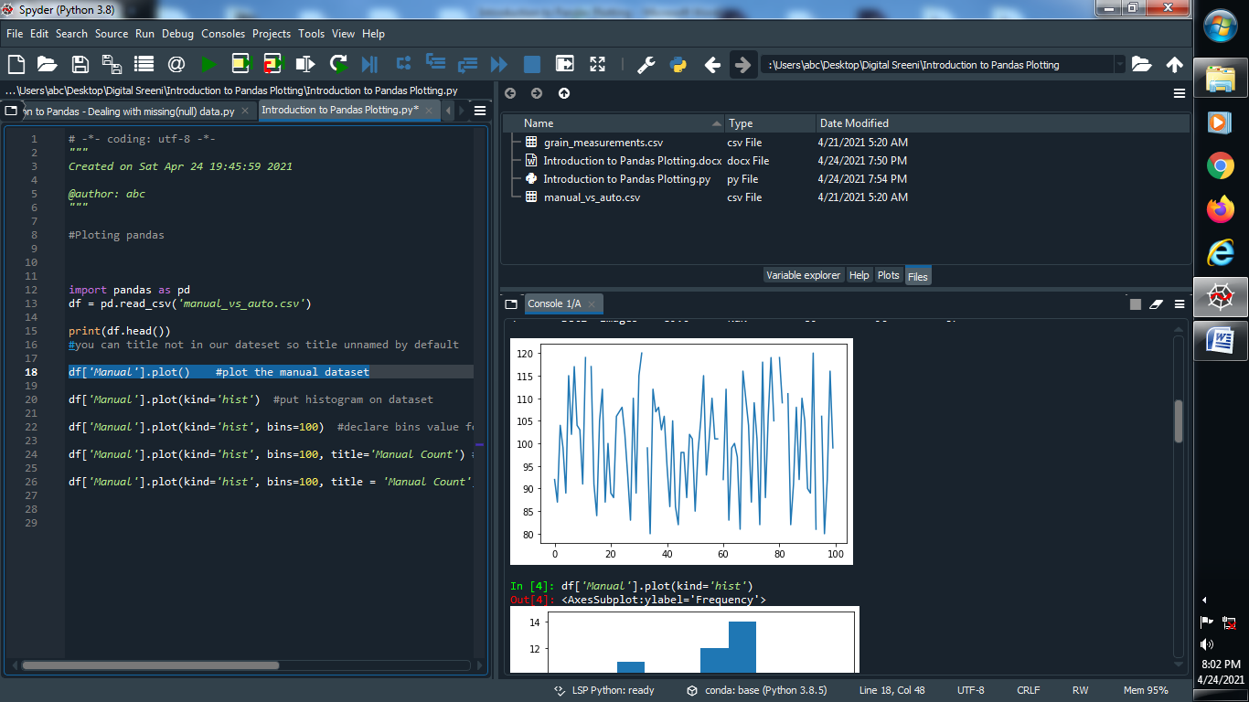

**(2) Put the histogram on the dataset :**

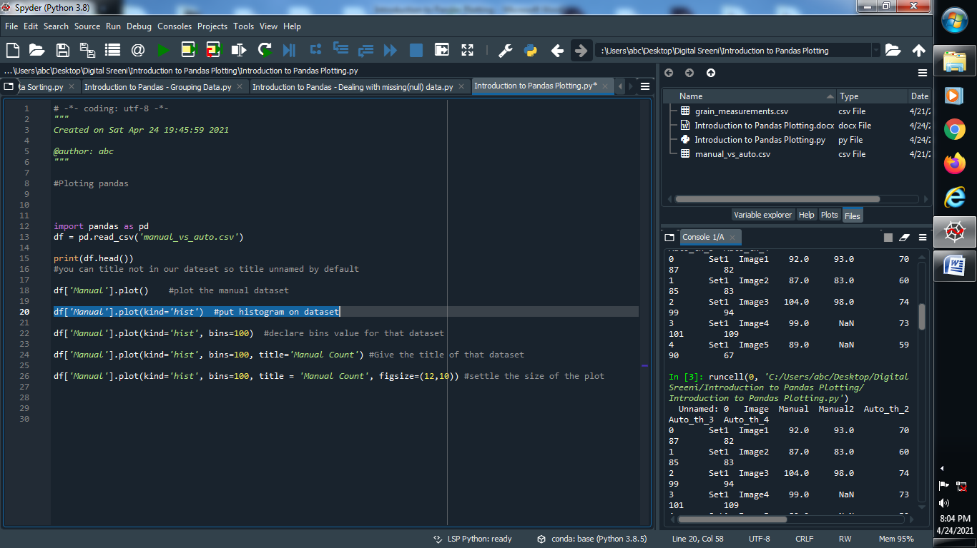

**Output :**

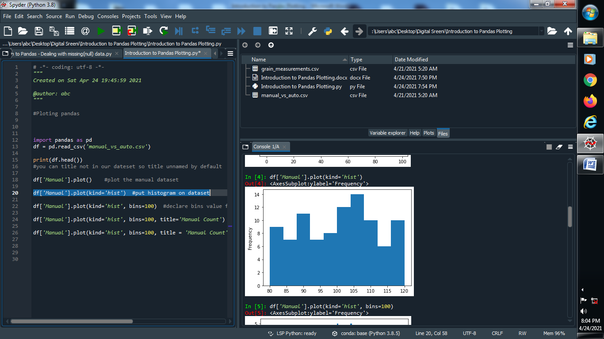

**(3) Put the bins value of the histogram :**

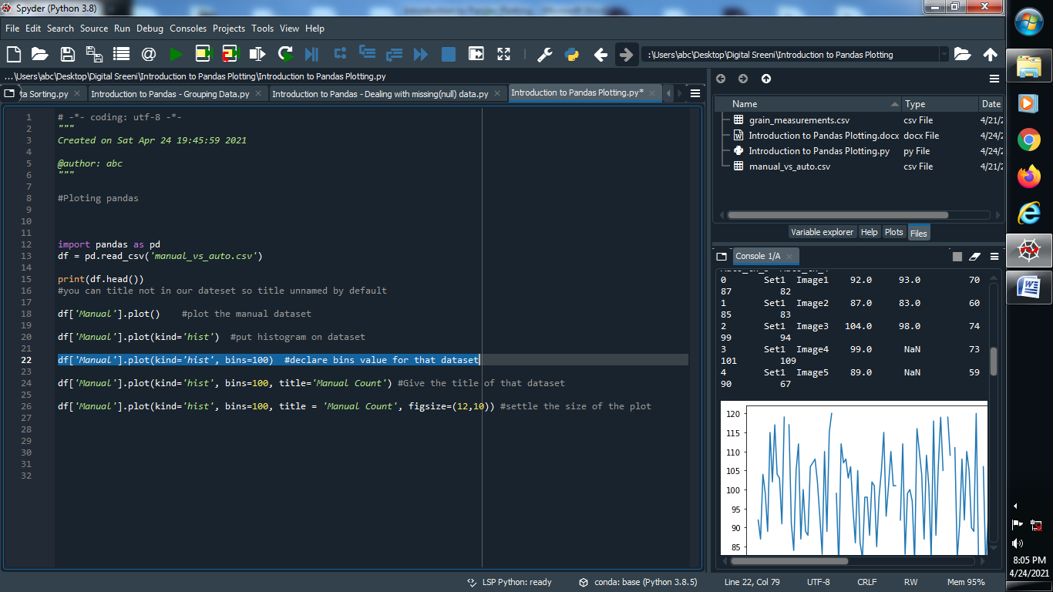

**Output :**

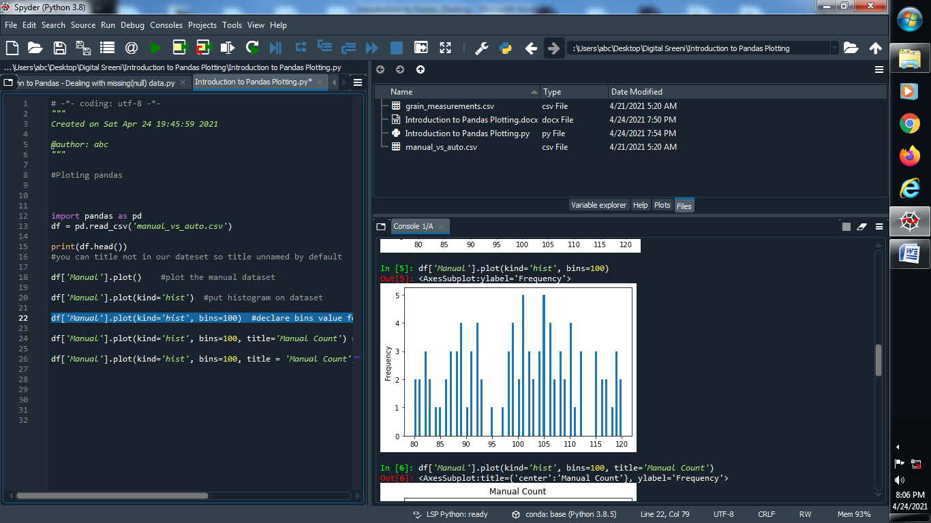

**(4) Give the title for the dataset :**

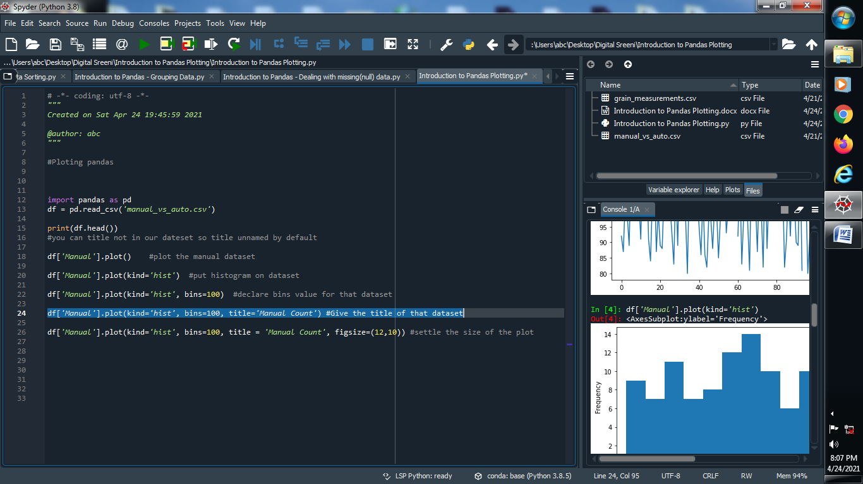

**Output :**

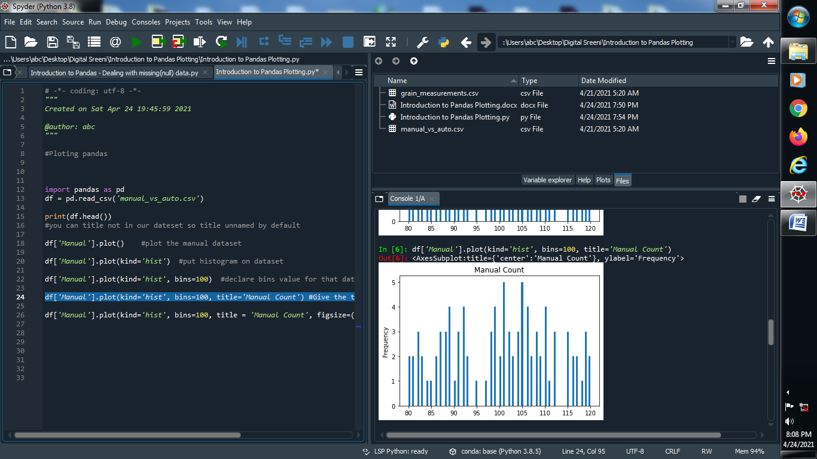

**(5) Fix the size of the plot :**

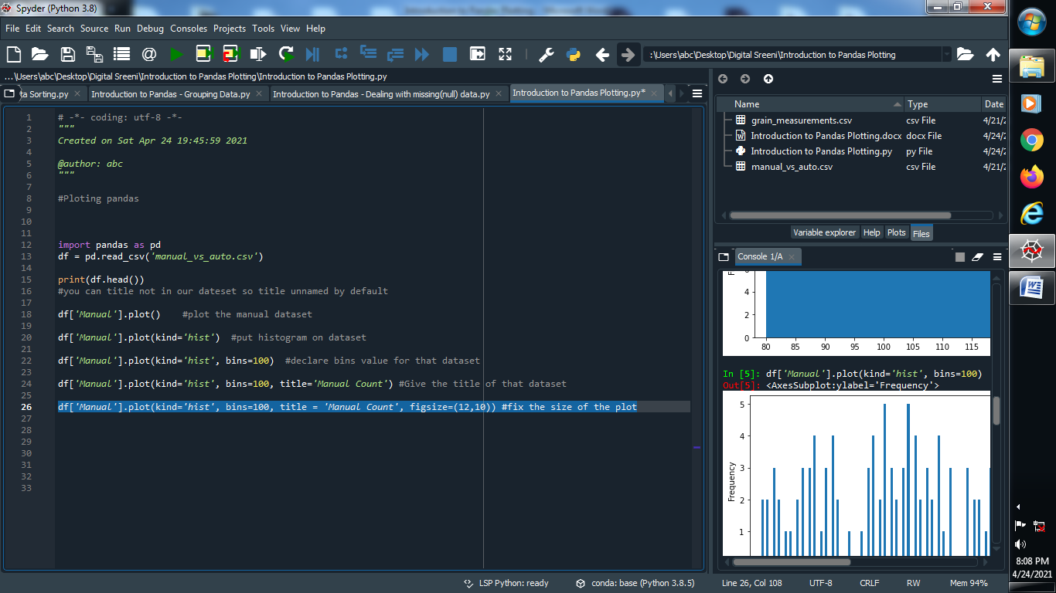

**Output :**

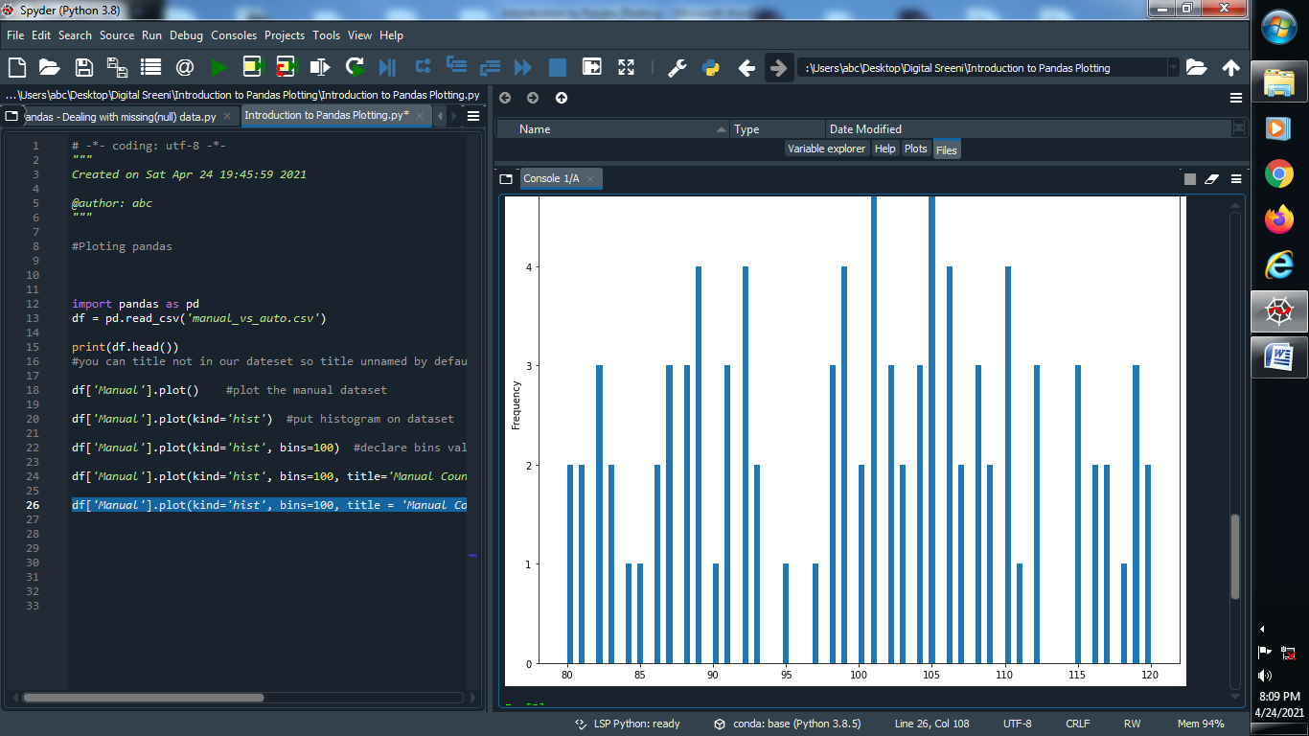

**(5) Plot the set1 on the dataset manual :**

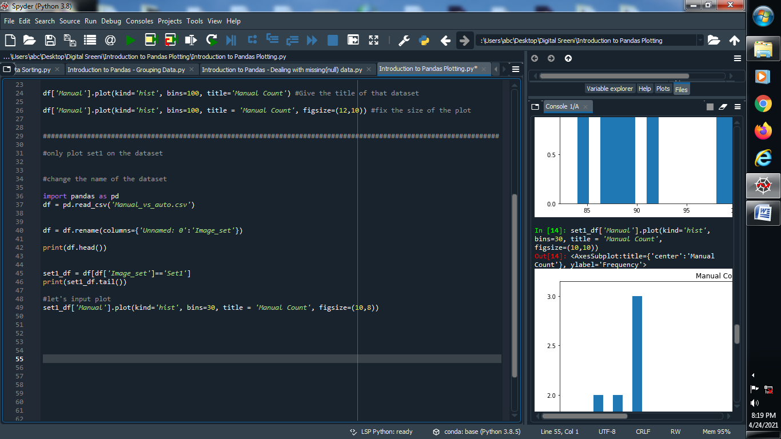

**Output :**

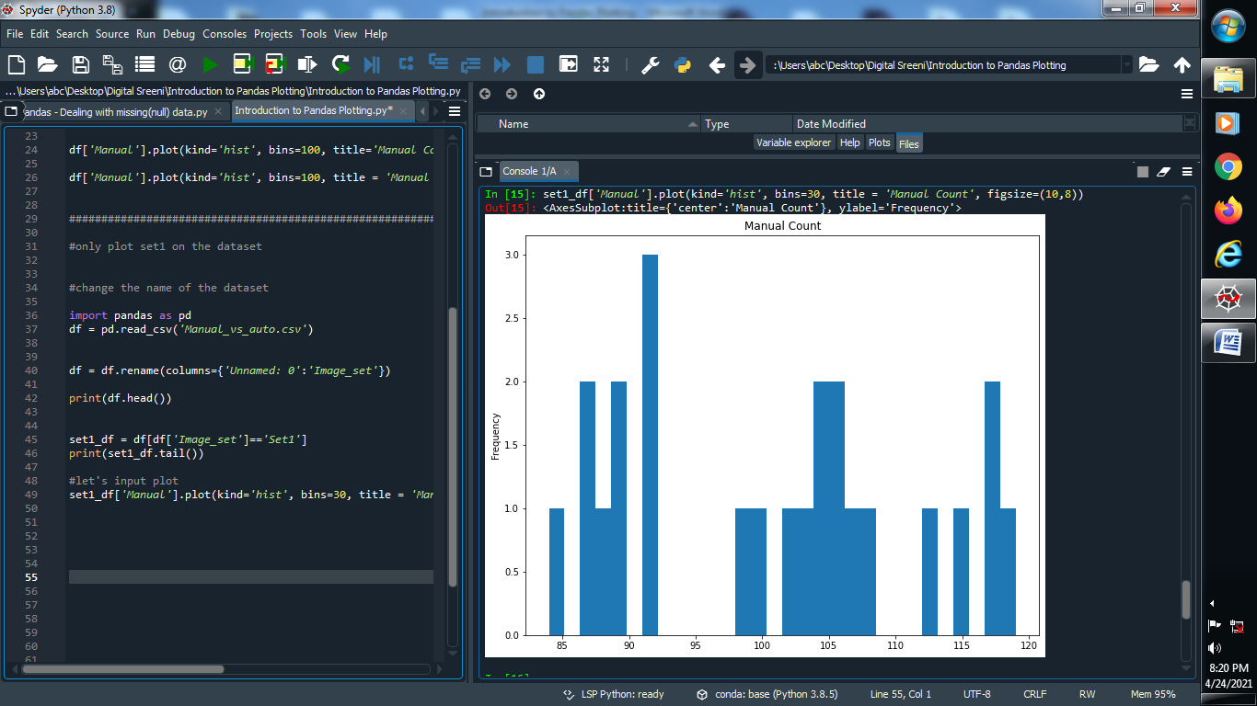

**(6) Rolling Average on the dataset :**

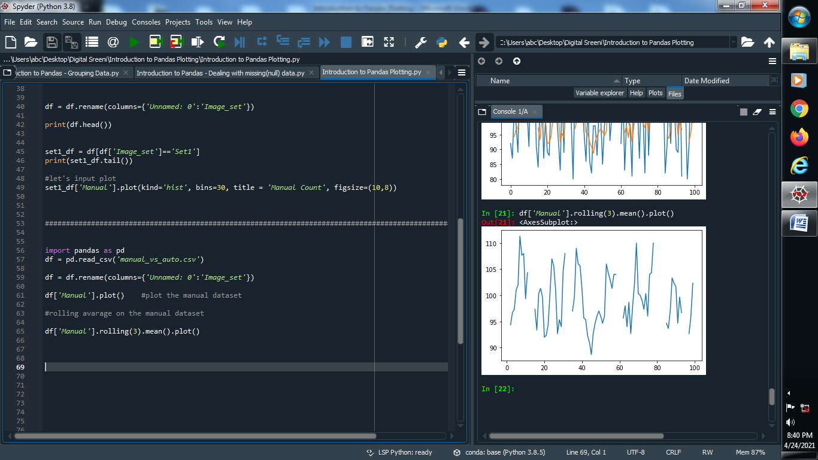

**Output :**



**(7) Graphical representation of the dataset :**

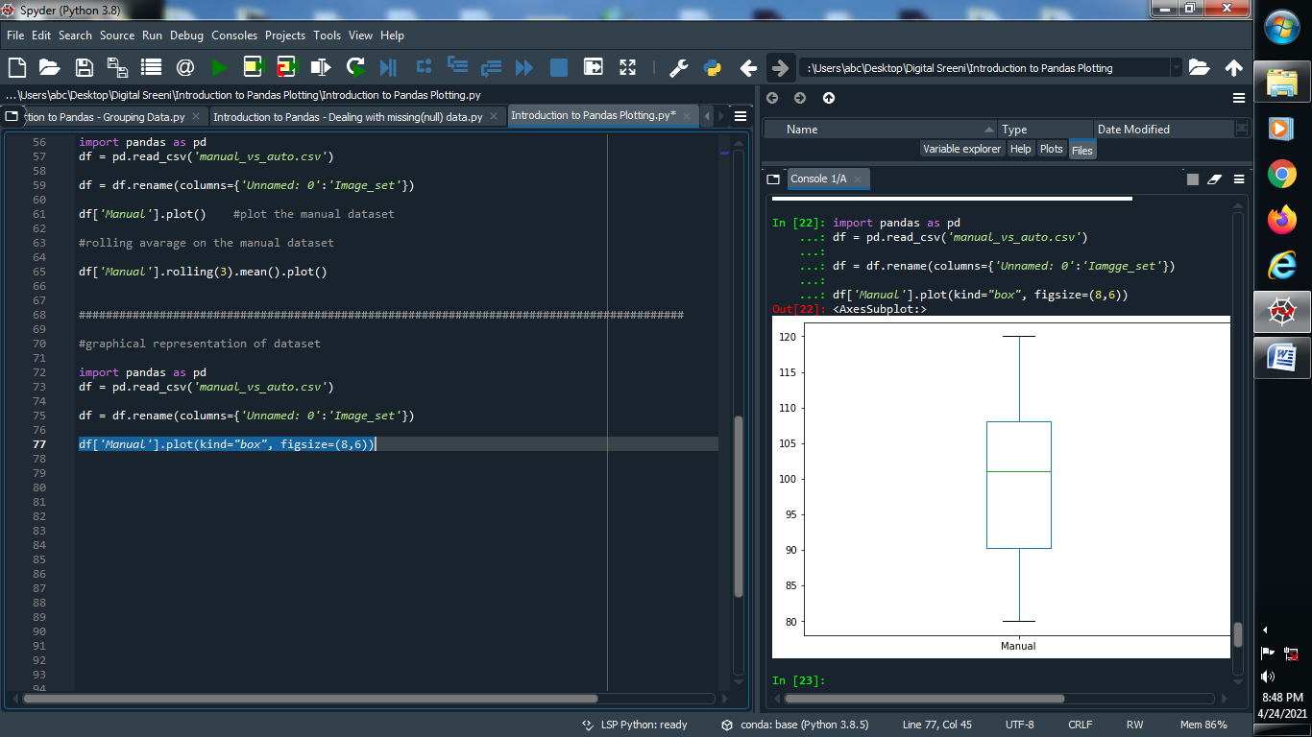

**Output :**



**(8) Graphical representation using scatter :**

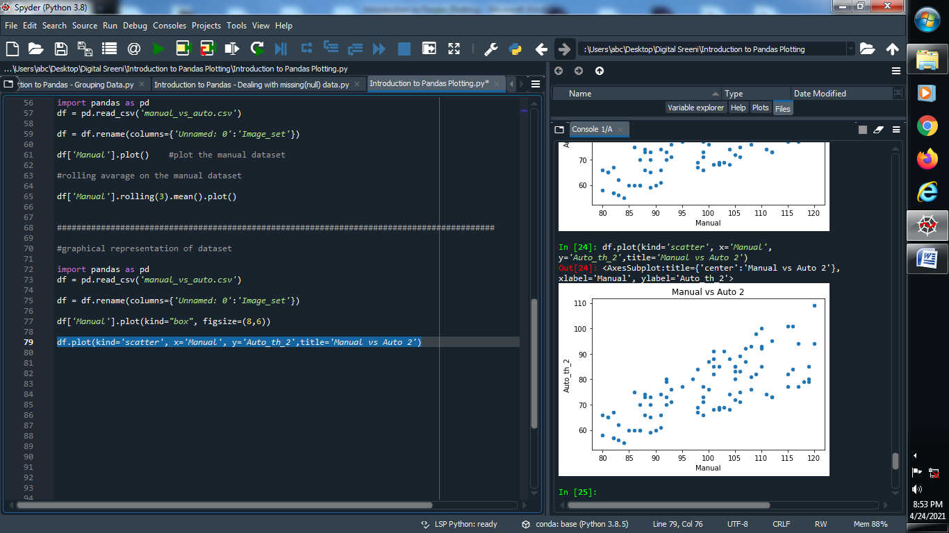

**Output :**



**(9) Using functions to create category is low or high :**

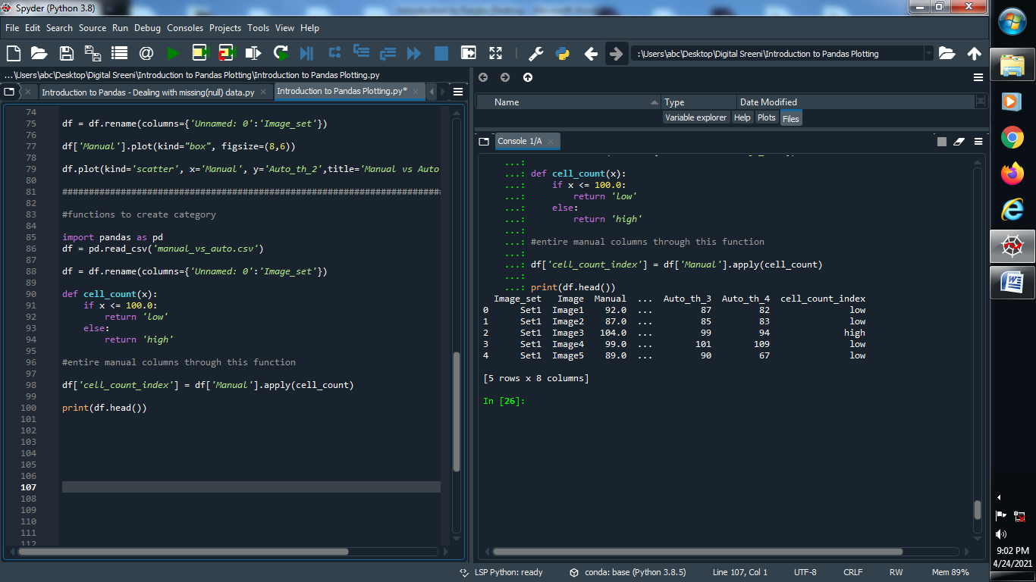

**Output :**

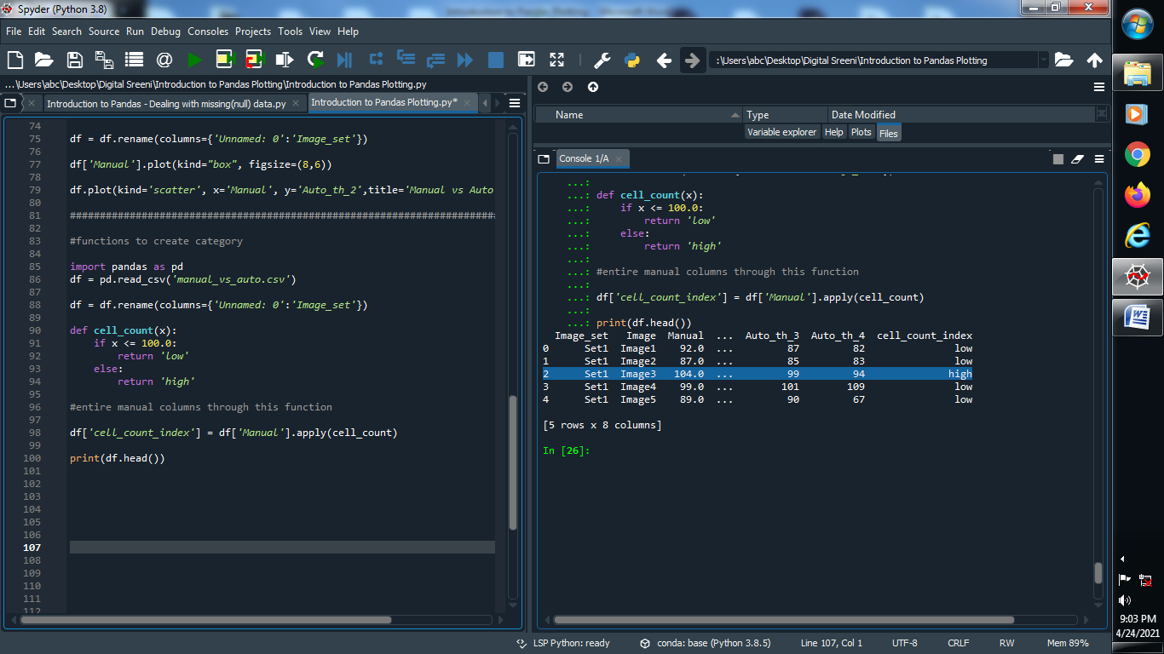

**(10) Add this category column into the database :**

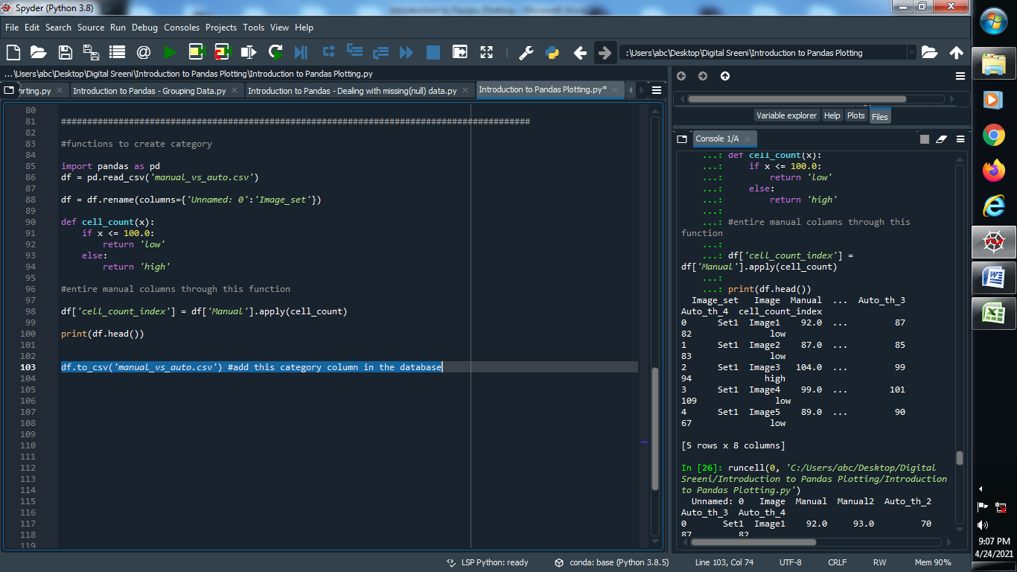

**Output :**

**You can see that cell_count_index column add into the dataset**

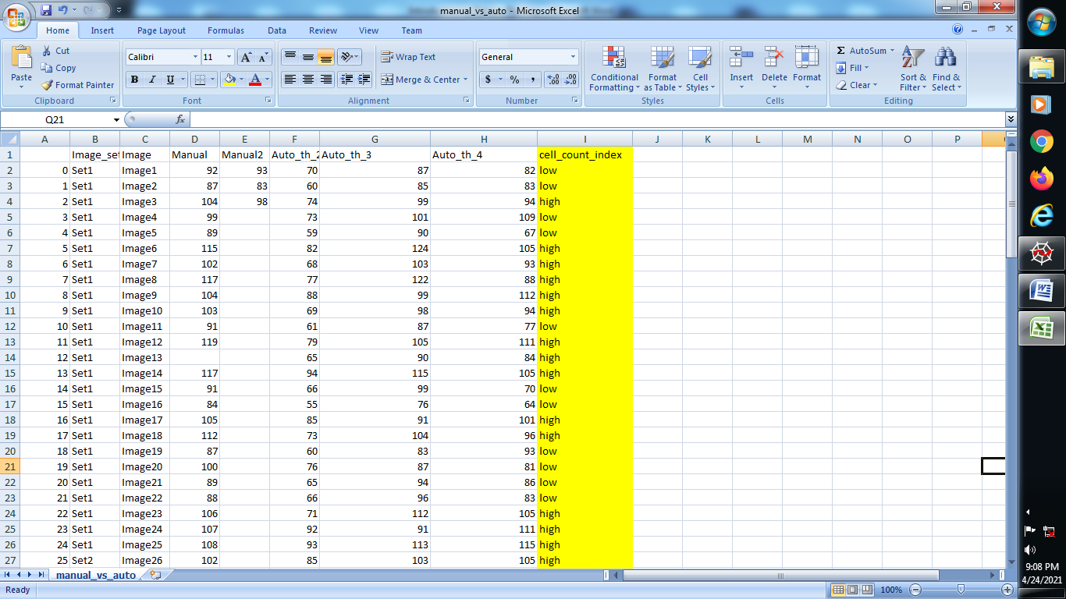

**(11) Putting the plot into above function category :**

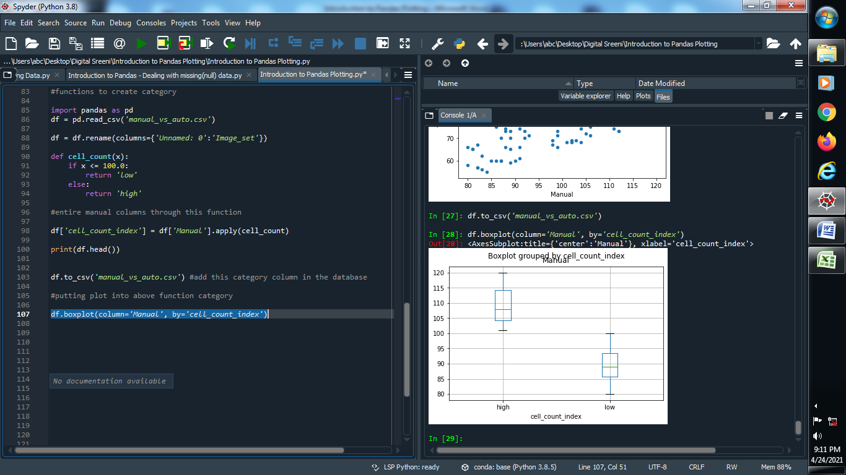

**Output :**

